**Progress Report - Week 8**

Group name: Team A - VARS  
Group members: Rahil Patel, Vrund Patel, Sarthak Awasthi, Arpit Paranjpe

Our plan for the previous week:

* Rahil Patel
  + Code the front-end page for the COVID-19 vaccine alert system
    - Adjusted Arpit’s existing styling on the vaccine alert system page
  + Helped the team visualize the design for the main dashboard homepage
  + Began to add the main dashboard homepage to our project
* Vrund Patel
  + Set up the GitHub repo with initial commit for design layout details and responsibilities
    - 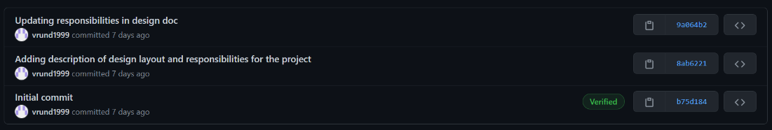
  + Creating the server.ts file and setting up hostname and port and any needed route handlers
    - 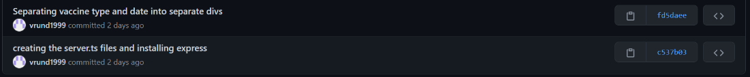
  + Setting up the route handler to retrieve the covid data/news
    - The route handler will make axios requests to the API’s to get the covid data and news from an API
    - 
  + Assisted the team in designing the webpages
* Sarthak Awasthi
  + Created the mongoDB database and document on Mongo CloudSet up and connected to the Database using Node.js and MongoDB driver
  + 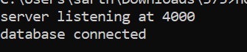
  + Inserting image...
* Arpit Paranjpe
  + Designed the main webpage which will display the covid data/news based on the country the user inputs.

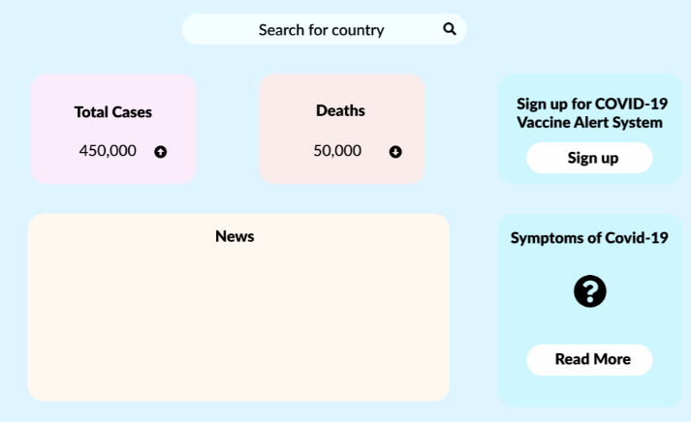

* + Designed the alert webpage which will allow the user to enter their first name, last name, email, their covid vaccine type (brand), and when their appointment is. This information will be used to alert them a day or two before their appointment to be ready and alert for their appointment, so they don’t forget.

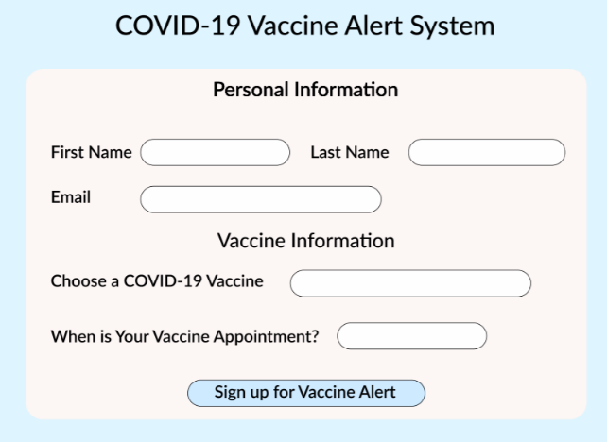

We are on track so far with what was planned in the last week.

Our plan for the upcoming week is:

* Rahil Patel
  + Finish coding the front-end page for the main dashboard homepage
    - Add the HTML for link to the vaccine alert system page
    - Add the HTML for ‘Symptoms of Covid-19’
  + Finish adjusting styling for the main dashboard homepage
* Vrund Patel
  + Integrating the server route handler with the front end to retrieve covid data/news based on user input.
* Sarthak Awasthi
  + Work on auto-search system for countries on the homepage
* Arpit Paranjpe
  + Working on implementing the HTML main webpage to display the covid data/news
  + Helping Vrund with connecting the HTML elements and adding any event handlers to make fetch requests to the server to retrieve the covid data/news.